 | LEAP FOOD iDEA lIST  Use the LEAP Food Idea List in conjunction with your Food Reintroduction Schedule and Menu Planner to develop a healthy and delicious eating plan. Always be sure to check package labels for other ingredients that may not be allowed on your diet. For further info, check out www.foodsubs.com.

Proteins:  Meats &  Poultry |  |  |  | 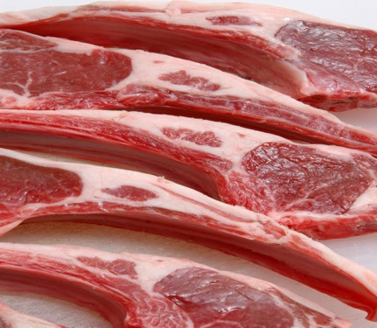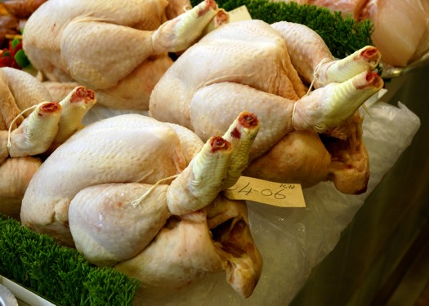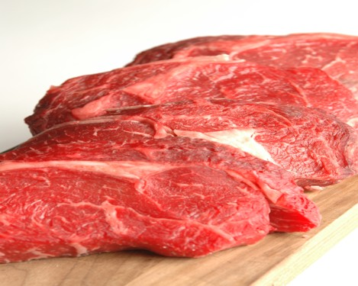
Beef, pork, or lamb: Any pure, all natural cuts without preservatives. Sometimes excess fat is a trigger for IBS, so choose lean cuts. Cook with a little water in a slow-cooker, or in a covered pan in a 325°F oven, or simmer on top of the stove for tender meats that make their own broth for gravies, sauces, soups, or stews.
Chops or steaks: Pan fried, baked, roasted, broiled, grilled. Breaded with flour or ground nuts.
Roasts: Braised, open-roasted, or on a rotisserie, pot roasts with allowed vegetables, seasonings, fruit. Slice for sandwiches or wraps, cut into pieces for salads.
Ground: Burgers, meatballs, ground meat in natural gravy, meatloaf with allowed grains and seasonings; stir fried, slow-cooked or casserole with allowed grains, vegetables and seasonings
Ribs: Bake, broil, or grill. Rub, marinate, or baste only with allowed ingredients.
Soups and stews with allowed vegetables, grains and seasonings.
Bacon and sausage not allowed unless homemade and/or ALL ingredients in them have also been allowed and individually introduced and well tolerated.
Sandwiches made with above meats. If no bread available, use cabbage or lettuce leaves to make a meat and vegetable wrap.
Chicken or turkey: Organic or all-natural whole poultry or parts. Roast, bake, broil, grill, slow-cook; simmer, or make into a soup or casserole with allowed grains, vegetables and seasonings.
Fried, rolled in allowed grains, bread crumbs, or ground nuts or seeds.
Stir-fried with vegetables.
Whole roasted or boiled. Serve hot, or chill and slice for sandwiches or chop for salads.
Eggs: Fry or scramble in allowed oil. Hard boiled. As frittata (see RECIPES) or quiche.
French toast with allowed bread and fruit topping or allowed syrup/sweetener.
Egg sandwich, tortilla roll-up, or lettuce wrap. Diced in salads; stir-fries with allowed grains and vegetables.
Beef | Roast, steak, stew meat, ground beef, other beef cuts, beef broth, beef gravy (with allowed broth and flour). Bake, broil, fry, roast, grill, slow cook, braise.
Chicken | Whole roast chicken, chicken breast, ground, thighs, legs, or wings. Fried chicken (allowed oils and/or flours/seasonings). Cornish game hen. Chicken soup and broth (homemade or allowed ingredients). Stew, roast, bake, broil, boil, fry. Caution with injected flavorings and additives.
Egg | Chicken eggs. Fried, soft or hard cooked, poached, egg white, egg yolk, powdered eggs, meringue. Scrambled, omelet, frittata (depending on recipe); stir-fries.
Lamb | Ground lamb, lamb chops, lamb roast, leg of lamb.
Pork | Pork chops, roast, tenderloin, steak, ground and other pork parts. Bake, broil, sauté, fry, stew. Ham cured with salt only. Bacon, ham, sausage IF made with allowed ingredients. Use only natural pork not injected with flavorings and additives.
Turkey | Whole turkey, turkey breast, boneless cutlets, ground turkey, turkey legs, thighs, wings. (Caution with ALL turkey products - MUST read label for allowed ingredients.) Roast, bake, fry, broil, patties, turkey loaf, homemade turkey nuggets.
Proteins:  Seafood |  |  | 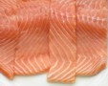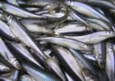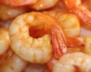
Seafood: Boiled, broiled or made into soup.
Casseroles with allowed grains and nuts.
Kabobs or stir fried with vegetables.
In cold salads.
Fish: Pan-fried with allowed breading, seeds or nuts and oils.
Dipped in oil, coated with allowed crumbs, flour, or ground nuts, baked in oven.
Baked or broiled with allowed veggies and spices.
Deep fried with allowed flour breading and oils.
Poached fish with water, allowed beverages and/or seasonings.
Chilled cooked fish served on salads.
Fish patties made with flaked fish and allowed breadcrumbs and seasonings.
Catfish |  | Fresh or frozen. Fry, broil, bake, grill, poach.
Clam |  | Fresh steamed clams, canned clams, minced clams. Check preservatives.
Codfish |  | Fresh or frozen. Fry, poach, bake, grill, broil. Use in fish chowder.
Crab |  | Fresh or frozen crab, steamed crab, canned crabmeat. Check preservatives.
Salmon |  | Fresh, frozen or canned (salmon, water, salt). Fry, broil, bake, poach; grill; patties.
Scallop |  | Fresh or frozen. Fry, steam, broil, boil, coat and bake. Check preservatives.
Shrimp |  | Fresh, frozen or canned. Bake, fry, broil, stir-fry, salad or soup. Check preservatives.
Sole |  | Fresh or frozen. Fillets, bake, broil, steam, poach, stuff (rolled).
Tilapia |  | Fresh or frozen. Whole or filets. Roast, broil, bake, stuff or fry.
Tuna |  | Fresh, frozen, or canned or pouch tuna (read label for allowed ingredients – fish, water, salt). Bake, broil, poach or fry. Use in a tuna salad or sushi.

Other  Protein Sources |  |  |  |  |  | 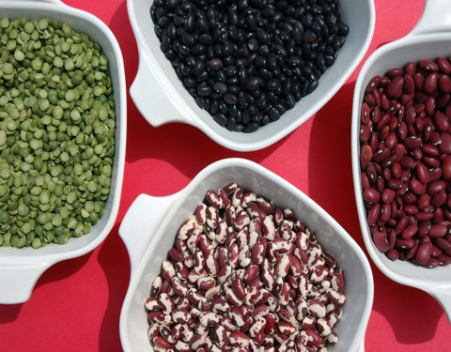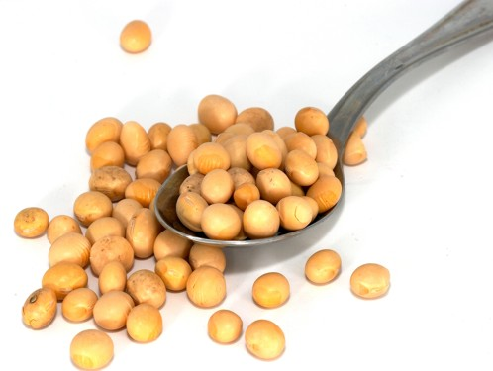
Garbanzo Beans |  |  |  | Also known as chickpeas. Fresh or canned. Gram flour, garbanzo bean flour.
Lentil |  |  |  | A small flat bean that can be cooked into sauces and stews, or used in vegetarian burgers. Can also be cooked plain as a delicious soup with allowed seasonings and vegetables. Lentil pasta is also an excellent alternative to wheat based pasta.
Pinto Bean |  |  |  | Fresh cooked or canned pinto beans. Refried beans (fat free or allowed fat).
Soybean |  |  |  | Soybeans, edamame (green soybeans – good hot or cold), soy flour, soy protein powder, soy cheese (read label), tamari, cooking oils, soybean oil, textured vegetable protein (TVP), hydrolyzed vegetable protein (HVP), tempeh, soy milk (check additives). Scrambled tofu with allowed vegetables and seasonings makes an excellent replacement for scrambled eggs.
Starches |  |  |  |  | 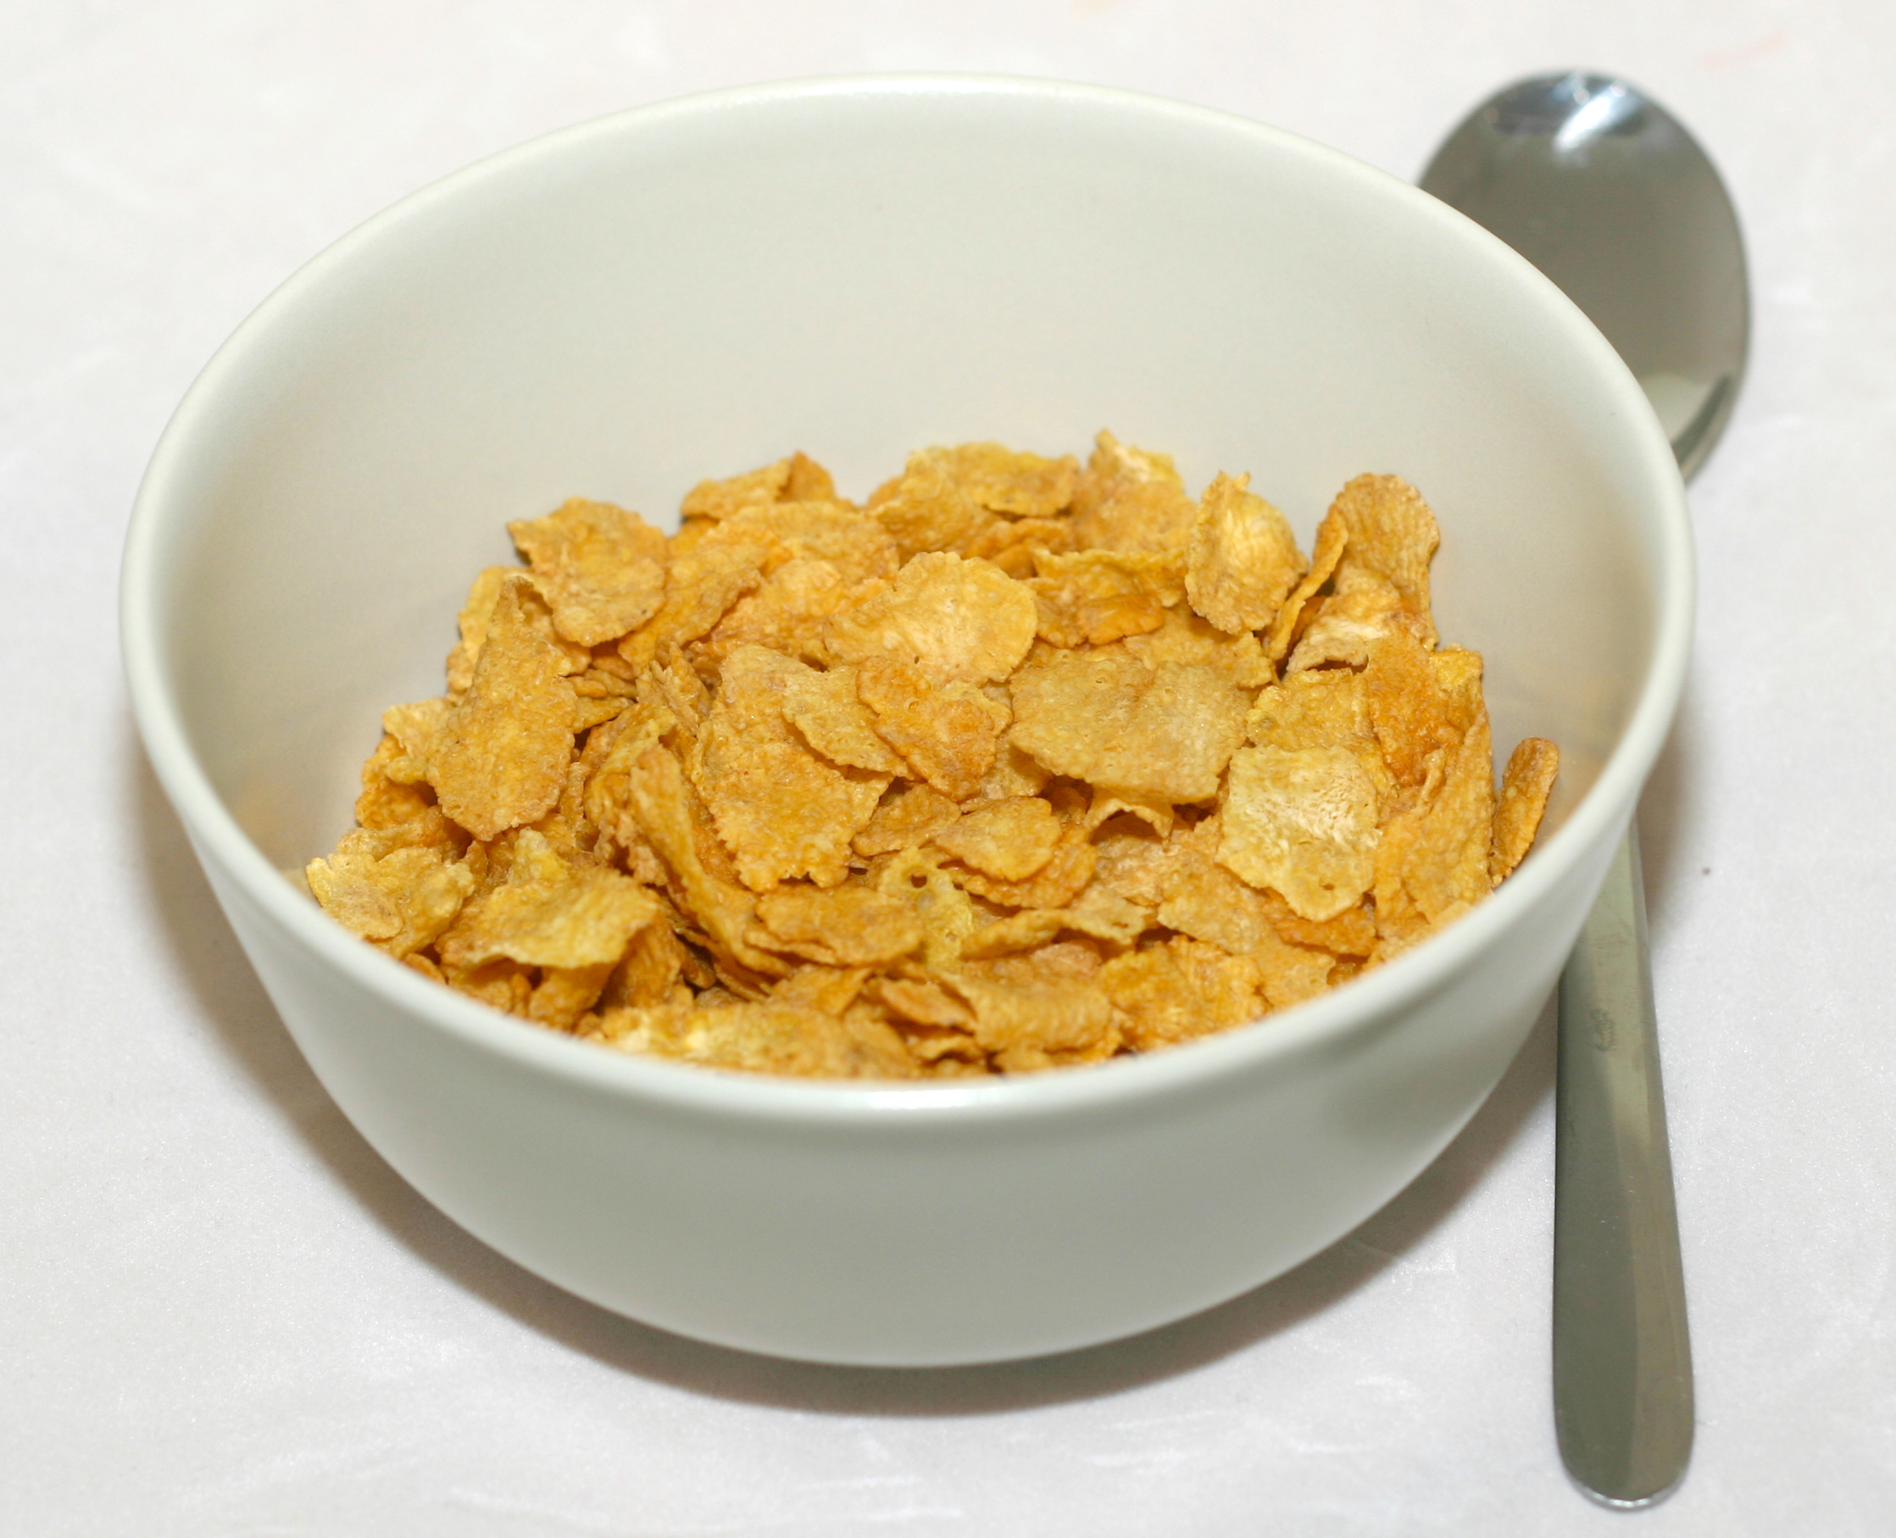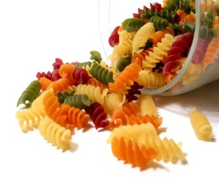
Starches and Grains: Whole grain pilaf, steamed, cooked then stir-fried with allowed vegetables, proteins and seasonings. Allowed bread made into stuffing, croutons for salad or ground for bread crumbs for meatloaf or breading for protein.
Granola-type mixtures of grains, fruits, nuts, seeds, oils.
Sandwiches made with allowed breads and proteins and spreads.
Tortilla roll-ups with allowed meat, cheese, vegetables and spreads.
Amaranth |  | Whole amaranth seeds, amaranth porridge and flour, amaranth leaves available in Asian stores also called Chinese spinach, hiyu, non-toi-moi, yin choy, Amaranth noodles.
Barley |  | Barley grains, instant barley, barley cereal, pearled barley, barley flakes, barley flour, barley sugar, barley malt syrup, malt vinegar.
Buckwheat |  | Whole buckwheat groats, buckwheat flour, buckwheat noodles (soba), kasha, cream of buckwheat (hot cereal).
Corn |  | Corn on the cob, frozen corn, canned corn, popcorn, corn meal, polenta, corn starch, corn oil, corn cereal, corn syrup, dextrose, maltodextrin, hominy, grits, fructose powder, corn chips and tortillas, corn pasta (read label for allowed ingredients).
Kamut |  | Kamut is a supposed wheat alternative, but is actually very similar antigenically to wheat. If you have a wheat sensitivity of any kind it is best to stay away from kamut until later phases and proven “safe” for you. Puffed kamut, kamut bread, kamut tortillas, kamut flour, and kamut pasta.
Millet |  | Millet grain or flour, puffed millet. (Use whole millet for pilaf dishes.)
Oat |  | Whole oat groats, rolled oats, instant rolled oats, oat flour, oat bran. Use as grain, granola, cereal, tortillas, patties, pancakes, baking ingredient or for meatloaf, veggie burgers.
Quinoa |  | Quinoa, quinoa flour, flakes and pasta (read label for other ingredients).
Rice |  | Plain rice (brown, basmati or white), puffed rice, rice cakes, rice pastas (many shapes), bread or crackers (read labels for allowed ingredients), rice noodles, rice “spring roll” wrappers, cream of rice cereal, rice flour, mochi (Japanese rice puff), rice syrup, sake (rice wine), rice vinegar, rice bran oil. Rice milk (read labels). Some of these items best found in Asian markets. (Wild rice is untested and is not a true rice.)
Rye |  | Whole rye ‘berries’, rye flakes, rye flour, Wasa Light Rye Crisp crackers, Ryvita crispbread (check ingredients), cream of rye cereal, pure rye bread. (Rye bread usually contains wheat)
Spelt |  | Spelt is a supposed wheat alternative, but is actually very similar antigenically to wheat. If you have a wheat sensitivity of any kind it is best to stay away from spelt until later phases and proven “safe” for you. Whole or flaked spelt, whole-grain or white spelt flour. Spelt breads, tortillas, (read labels), pastas in many shapes.
Sweet Potato |  | Sweet potato/yam: Baked, mashed, steamed, oven fried. Canned yams (read label for allowed ingredients). Sweet potato flour.
Tapioca |  | Tapioca root and cassava root are very similar and are used like white potatoes. Look for them in Hispanic or Asian markets. Tapioca flour is used commonly in gluten free recipes.
Wheat |  | Whole wheat ‘berries.’ Wheat flakes, wheat flour, whole-wheat flour, white wheat flour, all purpose flour, puffed wheat cereal, shredded wheat, bulgur, pasta (spaghetti, macaroni, orzo, etc.), semolina flour, pure wheat bread, spring roll wrappers (found in Asian markets).
White Potato |  | Fresh, frozen and canned potatoes (read label-sulfites). Hash browns, shredded, French fries (read labels if not homemade), potato flour, potato starch. Bake, boil, steam, mash, shred, hash brown, fry, oven fries, potato patties or pancakes. Use in soups and stews.
Vegetables |  |  |  |  |  |  | 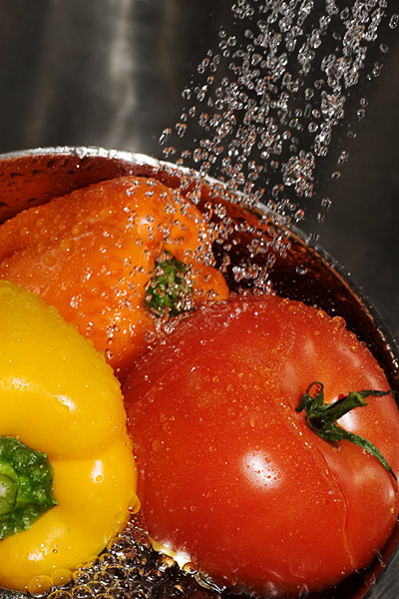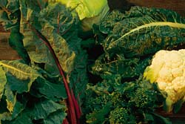
Vegetable Ideas: Fresh, steamed, oven roasted, stir-fried or microwaved.
Salads – Assorted greens, veggies, fruits, nuts, grains, seeds, protein, beans, cheese, herbs, croutons with allowed breads. Serve with allowed dressings or vinaigrette.
Soups – Just limited by your imagination.
Cut up and served raw with dip or nut butters or allowed spread.
Baked and/or stuffed with allowed seasoned pilaf or cheese or nut sauces
Asparagus |  |  | Fresh, frozen or canned asparagus.
Beet |  |  | Raw, baked, cooked or canned red beets, beet greens. (Beet sugar is related.)
Broccoli |  |  | Fresh or frozen broccoli, broccoli slaw (with carrot and cabbage).
Cabbage |  |  | Fresh cabbage, boiled, fried or steamed cabbage, shredded cabbage, sauerkraut. (Homemade slaw with allowed vinegars, oils, seasonings.)
Carrot |  |  | Fresh carrots, baby carrots, canned carrots, frozen carrots, carrot juice. Carrot slaw (homemade with allowed ingredients), carrot sticks, steamed, glazed carrots.
Cauliflower |  |  | Fresh or frozen. Mashed, steamed or raw cauliflower.
Celery |  |  | Raw or cooked fresh celery, celery juice, celery seed.
Cucumber |  |  | Sliced, chopped or grated cucumber. Pickles (check labels).
Eggplant |  |  | Fresh eggplant. Bake, roast, fry, broil, mash, puree.
Green Pea |  |  | Fresh, frozen, canned or dried peas, peapods.
Green Pepper |  |  | Green peppers: Fresh, frozen, or dried. Salads, sautéed, roasted, stuffed, baked.
Lettuce |  |  | Fresh head lettuce. Green or red leaf lettuce, romaine. Salads, dice for soup, place on sandwiches. Use leaves as a bread substitute, rolling foods in lettuce leaves for “sandwiches” to make wraps. (“Baby greens” or “mixed greens” may contain leaves from the mustard/cruciferous family.)
Lima Bean |  |  | Fresh, frozen or canned lima beans. Succotash (contains corn & beans)
Mushroom |  |  | Fresh, canned or dried mushrooms. Fry, sauté, bake, use for soup. Stuffed mushrooms (with allowed ground meat or seasoned grain like polenta).
Okra |  |  | Fresh or frozen okra, plain, in stew or soups. (Bread and deep fry with allowed ingredients; or dip in oil, coat with flour or crumbs, and oven bake.)
Onion |  |  | Fresh onions (sauté, bake or fry or as soup/stew ingredient). Dried onion, minced onion, onion powder, onion salt (watch for sulfites in dried products if reactive).
Spinach |  |  | Fresh, frozen, canned, dehydrated. Use fresh for salad, chopped in soup, casseroles or egg dishes.
String Bean |  |  | Fresh, frozen, canned, or dried as a snack. Boil, sauté, stir-fry, soups, stews.
Tomato |  |  | Fresh, canned or dried tomatoes - whole, diced, sauce, puree, paste. (Read labels)
Yellow Squash |  |  | Fresh yellow squash for salads. Stuff, bake, broil, fry, steam, microwave, sauté, stir-fry, grate for pasta substitute.
Zucchini |  |  | Fresh zucchini for salads. Stuff, bake, broil, fry, steam, sauté, fry, microwave, grate for pasta substitute. Top slices with allowed spreads. Zucchini milk (homemade).
Fruits |  |  |  |  |  | 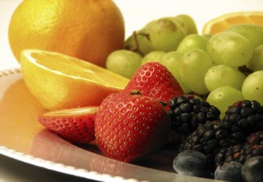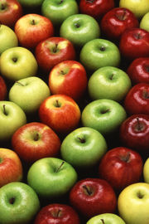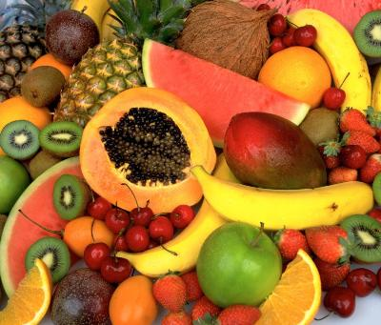
Fruit Ideas: Fresh fruit, mixed fruit, fruit juice, fruit puree, fruit smoothies, baked fruit with nut or granola topping, broiled fruit with allowed spices, cooked fruit soup, frozen fruit sorbet or ices. Fruit cut into pieces and frozen or purchased frozen makes a refreshing snack. Fruit “butters”.
Apple | Whole apples, apple butter, apple cider, apple cider vinegar, apple juice, apple sauce, dried apples or apple chips (read labels for other ingredients).
Apricot | Fresh apricots, apricot oil, dried apricots, baby-food apricot puree.
Avocado | Avocado, avocado oil. Slice for salads; mash or blend with allowed ingredients for tasty spreads and dips.
Banana | Fresh banana, banana chips, ‘fried’ or frozen banana, baby-food bananas.
Blueberry | Fresh, frozen, vinegar, pure blueberry juice. Dried blueberries (check ingredients).
Cantaloupe | Fresh, frozen cantaloupe, cantaloupe juice. Pureed for shake.
Cherry | Fresh, frozen or canned cherries, pure cherry juice, cherry butter. Dried cherries (check for sugar, corn syrup, citric acid).
Cranberry | Fresh; frozen, dried, pure 100% cranberry juice. Craisins® (beet and cane sugar).
Grape | Fresh, frozen or canned grapes. White or purple grape juice (fresh, frozen or canned). Wine, wine vinegar, raisins. Sulfites are often used in grapes/grape products. Preservatives or other ingredients often used in wine.
Grapefruit | Fresh, frozen or canned grapefruit or grapefruit juice. Check for added ingredients.
Honeydew Melon | Fresh, frozen or pureed for shake.
Lemon | Fresh lemon. Fresh, bottled, frozen or dried lemon juice. Watch for sulfites or other preservatives if sulfite or benzoate/sorbate sensitive.
Mango | Fresh mango. Mango juice or fruit mix, mango puree, dried mango, mango vinegar. Check labels for preservatives/sweeteners.
Olive | Black olives, olive oil. Read label for allowed ingredients.
Orange | Fresh oranges. Fresh or canned mandarin oranges (read label for allowed ingredients). Fresh or frozen orange juice. Orange juice concentrate as alternative sweetener, such as in a sauce or glaze for meat.
Papaya | Fresh, frozen, canned, dried (check ingredients). Papain (digestive enzyme).
Peach | Fresh, frozen, canned, pureed or dried peaches. Baby food peaches.
Pear | Fresh or canned pears. Pear juice (read label carefully); added to other fruits canned in juice. Baby food pears.
Pineapple | Fresh, frozen, canned pineapple or pineapple juice, dried, candied (check ingredients). Sliced, chunk, tidbits. Bromelain (digestive enzyme).
Plum | Fresh or canned plums. Prunes, prune juice. Plum vinegar (tyramine, check sulfites).
Raspberry | Fresh, frozen or canned raspberries (watch for allowed ingredients). Pure juice.
Strawberry | Fresh, frozen, dried (read label for any possible added sugars).
Watermelon | Fresh watermelon. Watermelon juice.

Dairy/Misc. |  | 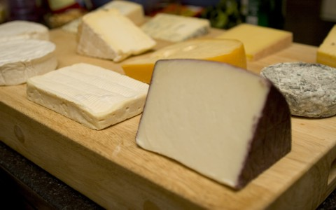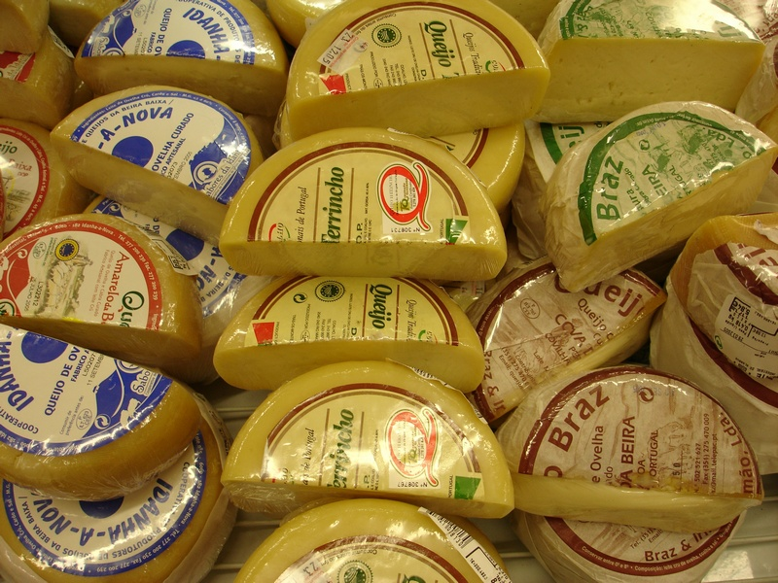
American Cheese | American cheese (read labels). (May tolerate mozzarella, cheddar or other cheeses with only milk, enzymes, and salt and no preservatives.)
Cheddar Cheese | Available with coloring or no coloring.
Cottage Cheese | MRT testing is for the ‘DRY CURD’ cottage cheese, not creamed. Buy plain (cultured milk, salt, enzymes); or rinse curds initially. Read labels carefully.
Cow's Milk | Fresh milk. Skim, 1%, 2%, whole, lactose-free. Canned, evaporated, shelf-stable (caution MSG from processing), non-fat dry, half and half, ghee, butter.
Cocoa | Cocoa powder, baking chocolate, cocoa butter, pure bakers’ chocolate.
Coffee | Coffee, decaffeinated coffee, espresso, coffee beans.
Cola | MRT tests just the cola nut, not the entire “soda” drink. When all other soda ingredients are added back individually, then an entire “cola” can be tried.
Goat's Milk | Fresh or powdered goat’s milk. Goat cheese – maybe, if milk tolerated.
Tea | Black tea, green tea, oolong tea, orange pekoe tea, pekoe tea, decaf tea.
Whey | Whey protein powder.
Yogurt | Fresh plain yogurts. Check labels for additives. Organic preferred. Add allowed fresh, frozen or canned fruits and/or nuts and seeds. (Horizon-check pectin, Seven Star Farm, Dannon All Natural Plain Regular or similar plain.
Yeast Mix | Baker’s or brewer’s yeast.

Nuts  Seeds  Oils |  | 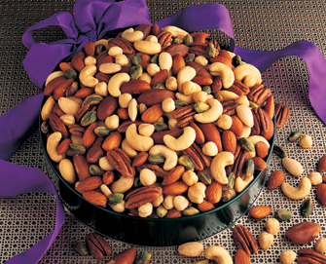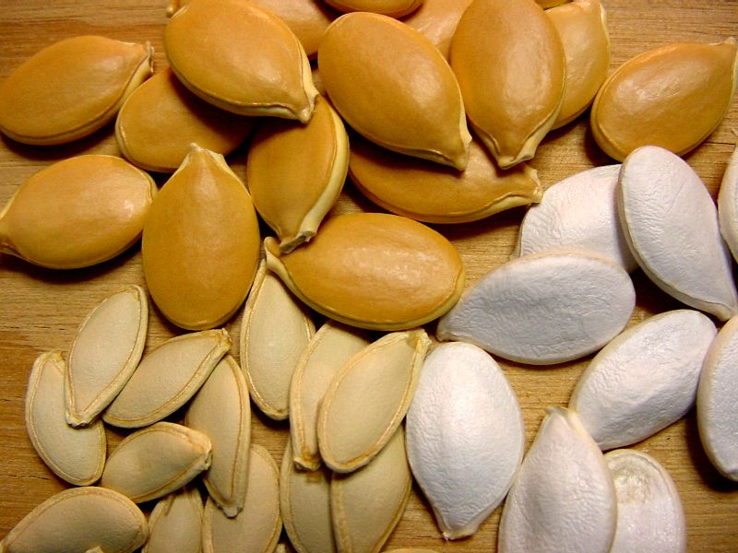
Almond | Whole, sliced or finely chopped almonds, almond butter, almond oil, almond paste and almond milk (read label for other ingredients).
Cashew | Whole or chopped cashews, cashew butter (check added oil), cashew milk.
Hazelnut/Filberts | Hazelnuts or filberts in shell or canned. Hazelnut oil, hazelnut butter - check oil and added ingredients.
Peanut | Peanuts in the shell. Raw peanuts, canned peanuts, whole, chopped. Peanut oil, fresh peanut butter (check label for allowed ingredients). Peanut flour.
Pecan | Pecans: In shell, whole, chopped, pecan flour. Pecan oil, pecan butter.
Pistachio | Shelled or in the shell pistachios (not red colored). Pistachio butter.
Sesame | Sesame seeds, sesame oil, tahini (sesame paste).
Sunflower Seed | Sunflower seeds, oil, butter. Check label for other added oils.
Walnut | Walnuts: In shell, whole, chopped, walnut flour. Walnut oil, walnut butter. Check label for added ingredients such as BHT in corn oil.

Flavor Enhancers |  | 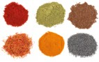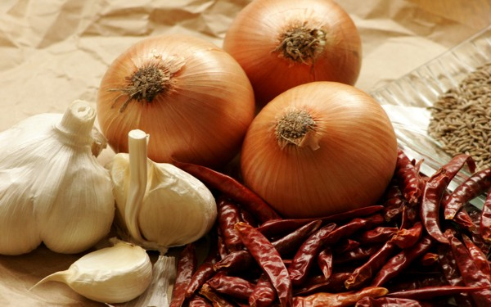
Basil | Fresh basil leaves, dried basil. (Basil pesto if other ingredients allowed.)
Bay Leaf | Usually found as whole leaf, added for flavor and removed (not eaten).
Black Pepper | Whole or ground black or white pepper. Peppercorns.
Cane Sugar | Cane white, brown, castor or turbinado sugar, cane syrup, cane juice. Cane molasses. Cane sugar cones. Cane vinegar. Note: If a label says “sugar” without specifying “cane” sugar, it may be “beet sugar” from sugar beets. You have to call the manufacturer (800# on label) to find out which sugar is used.
Carob | Carob powder.
Cayenne Pepper | Cayenne pepper.
Cinnamon | Ground or stick cinnamon, cinnamon tea.
Coconut | Fresh or grated coconut, coconut milk, coconut oil, coconut vinegar.
Cumin | Dried cumin powder. Cumin seed.
Dill | Dill spice. Dill weed, dill seed. (Great on salads or fish.)
Garlic | Fresh garlic. Chopped garlic. Baked garlic cloves. (Prepared garlic in jars may have untested ingredients.) Dehydrated chopped garlic. Garlic powder or salt. (Caution with dried garlic if sulfite sensitive.)
Ginger | Fresh ginger root. Pickled ginger root or ginger paste (read label for allowed ingredients.) Crystallized ginger root (cane sugar). . Dried ginger powder. Ginger capsules (check capsule source).
Honey | Honey of all kinds. (Honey may be high in salicylates.)
Leek | Fresh leek. (Use as you would use onion or for onion replacement.)
Maple | Maple syrup, maple sugar. Can be used as a sweetener.
Mint | Fresh or dried mint. Mint tea (read label for other ingredients).
Mustard | Mustard seed. Dry powdered mustard. (Prepared mustard-only with allowed ingredients.) Make mustard paste (dry mustard and distilled vinegar or water).
Nutmeg | Whole grated or ground nutmeg.
Onion | Fresh onions (sauté, bake or fry or as soup/stew ingredient). Dried onion. minced onion, onion powder, onion salt (watch for sulfites in dried products if reactive).
Oregano | Fresh or dried oregano.
Paprika | Dried paprika. Pimentos.
Parsley | Fresh or dried parsley. Parsley tea.
Poppy Seed | Poppy seed.
Turmeric | Powdered, dry turmeric. (Available in the spice section of market.)
Vanilla | Vanilla bean, pure vanilla extract (not vanilla ‘flavored’ or imitation vanilla). Even some pure vanilla extracts may contain corn. Spice Islands Pure Vanilla Extract is plain.

